Sgraffito Tile

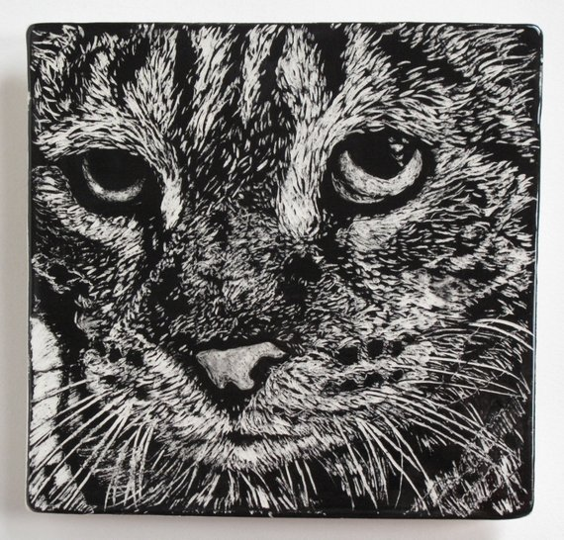
Sgraffito (in Italian "to scratch") is a decorating pottery technique produced by applying layers of color or colors (underglazes or colored slips) to leather hard pottery and then scratching off parts of the layer(s) to create contrasting images, patterns and texture and reveal the clay color underneath.
Believe it or not, this image is actually scratched into clay!

This is the closest we will get to drawing in Ceramics. (This technique is very similar to scratchboard in that we will scratch through the colored slip to reveal the white clay underneath.)

Think of an image you would like to create using this Sgraffito technique for our next project and design it on the 6x6 template on the back of this sheet.

Try to have your image display 50/50 black and white values.

You are encouraged to use your device to help with a reference image.

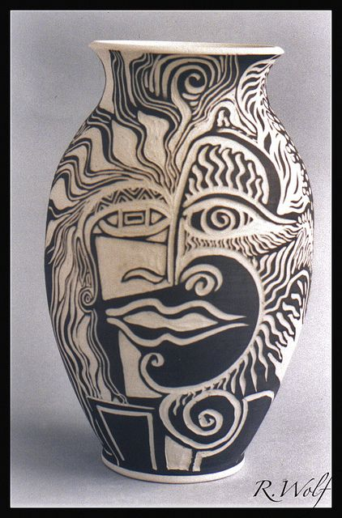
Below are other sgraffito images for inspiration:
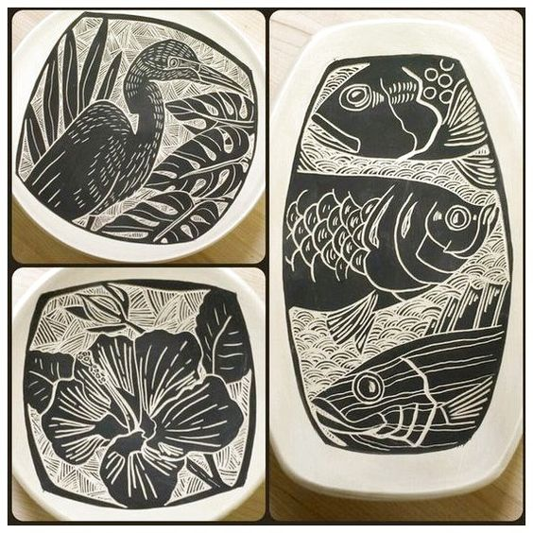
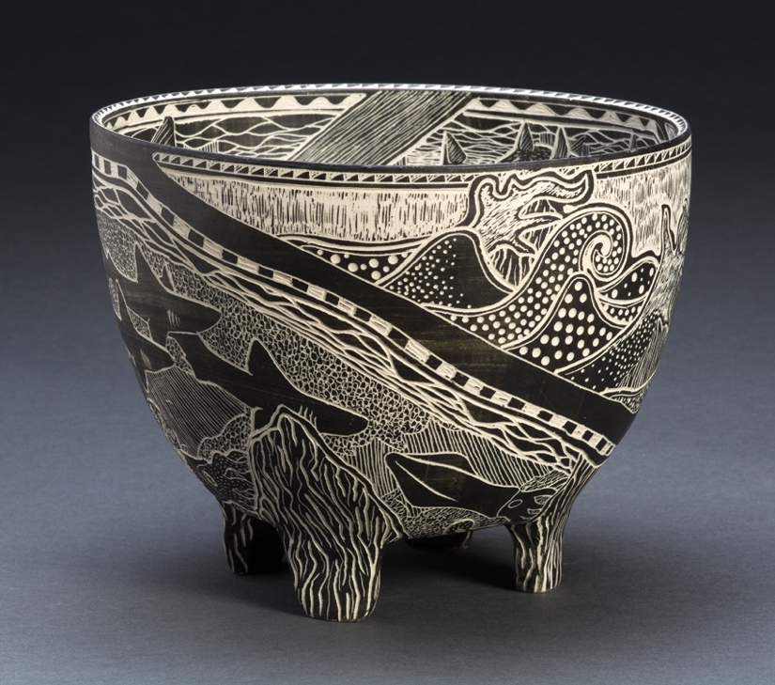

Create your Sgraffito design for our next project in the 6x6 square template below.

Lightly add shading to indicate the black and white values.

Feel free to use your device for ideas.

